How to Create Individual Buttons in Fireworks

- Create a new canvas by 200 x 200 72 dpi resolution

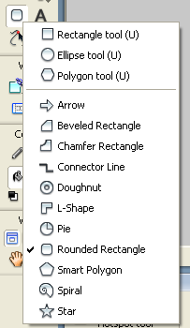
- Choose Edit > Insert > New Button> to create your button

- Choose rectangle tool Click and hold right button on the mouse– choose a different shaped button to the button you used on your navigation bar
- Drag out the required shape

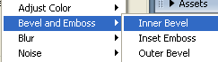
- Select the effects +
> select Bevel and Emboss > inner Bevel

- Select the text tool and type your text

- Select the Over tab > select Copy Up Graphic > re-select the button > select a another colour and change the fill for the button.

- Select the Down tab > select Copy Over Graphic make changes to the button

- Select Over While Down tab > Copy Down Graphic make changes to the button

- Select Done & save your button in an appropriate folder e.g. Unit 21 A04 folder

- Select Preview to try your button then press F12 to view on the web.

